**Challenge 03 - CSS Flex**

For this week’s challenge, you’ll need to create a whole web page with implemented CSS styles. Refer to the *screenshots & video* folders to see the exact look of the page.

Some of the items in the navbar should contain a dropdown menu when you hover over them. The mouse pointer here should be changed to a hand.

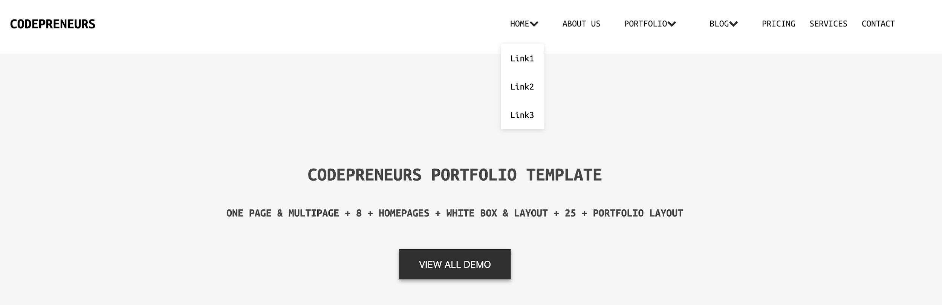

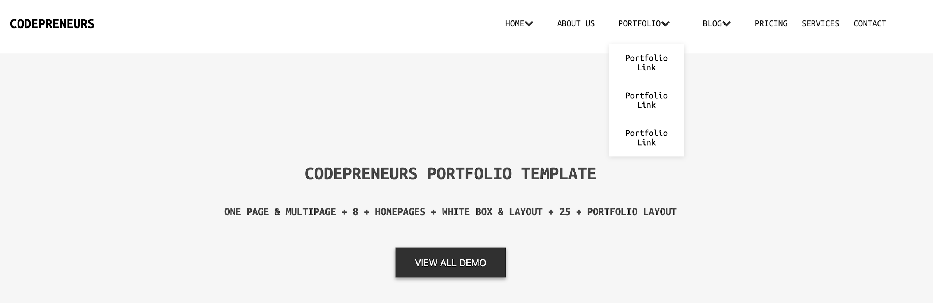

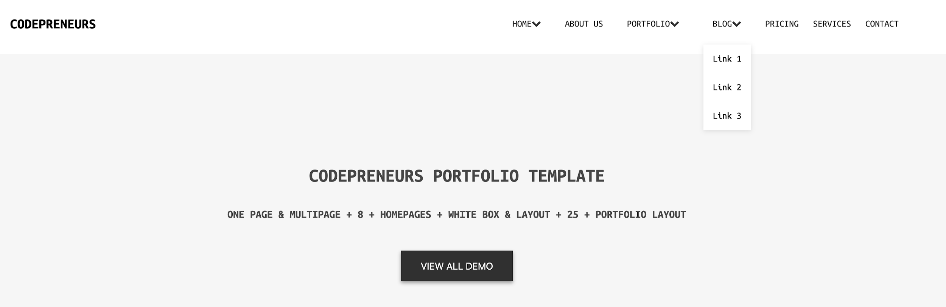

While hovering over the cards in the *Choose your demo* section, you should add a border around the card. You can see that in the picture below.

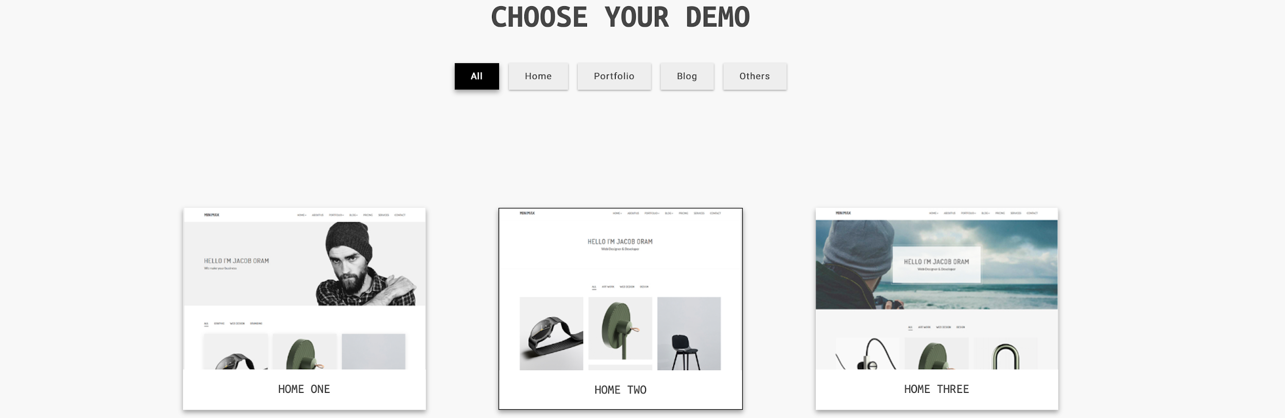

#### 

#### 

#### Evaluation system:

**1 point** - Whole page completed in HTML & CSS

**3 points** - Added the additional functionalities mentioned above

**5 points** - The page should be responsive to mobile devices. Additionally, when the page is open in responsive mode, the navbar menu should be switched to a hamburger menu that doesn’t need to be functional for now.

#### Deadline:

**1 week after its presentation, 23:59h end of the day.**

#### Hints:

* Use Flex to avoid any pain in positioning the elements.
* Read about box-shadow property on w3 schools.